**SMART LIBRARY MANAGEMENT SYSTEM**



ARPAN BANDYOPADHYAY (12200318067)

SASWATA DAS (12200318033)

ABHIRUP RAY (12200318071)

SOUVIK SRIMANI (12200318020)

Under the guidance of

**DR. JUIN ACHARJEE**

**(Assistant Prof. Department of ECE)**

Submitted in partial fulfilment of the requirement of the Degree of Bachelor of Technology of Maulana Abul Kalam Azad University (formerly West Bengal University of Technology). Kolkata

**Department of Electronics and Communication Engineering**

### St. Thomas’ College of Engineering and Technology

4 D.H. Road, Kolkata 700023

January, 2022

## Vision of the Department

* **To build a strong teaching and research environment to cater to the manpower needs in Industrial and Academic domains of the rapidly growing Electronics and Communication Engineering.**

## Mission of the Department

* **To produce certified industry-ready professional in Electronics and Communication Engineering, though innovative educational programs incorporating laboratory practices and project-based teaching-learning processes, in a modern environment.**
* **To create knowledge base of advanced technologies through research in the area of Electronics and Communication, for competitive and sustainable development of the country.**
* **To groom the department as a learning center to inculcate advancement of technology in Electronics and Communication Engineering with social values and environmental awareness.**

## Program Specific Outcome (PSOs)

After completion of program graduate engineer would have:

* **PSO1. Professional skills: An ability to apply the knowledge in Electronics and Communication Engineering in various areas, like Communications, Signal processing, VLSI and Embedded Systems.**
* **PSO2. Competency: An ability to qualify at the State, National and International level competitive examinations for employment, higher studies and research**

**Project Outcome (PO)**

* **After completion of the project, student will be able to:**

|  |  |  |
| --- | --- | --- |
| Outcome no. | Outcome Statement | Bloom’s Level |
|  |  |  |
|  |  |  |

**PROGRAM OUTCOMES (POs)**

**Engineering Graduates will be able to:**

1. **Engineering knowledge**: Apply the knowledge of mathematics, science, engineering fundamentals, and an engineering specialization to the solution of complex engineering problems.
2. **Problem analysis**: Identify, formulate, review research literature, and analyze complex engineering problems reaching substantiated conclusions using first principles of mathematics, natural sciences, and engineering sciences.
3. **Design/development of solutions**: Design solutions for complex engineering problems and design system components or processes that meet the specified needs with appropriate consideration for the public health and safety, and the cultural, societal, and environmental considerations.
4. **Conduct investigations of complex problems:** Use research-based knowledge and research methods including design of experiments, analysis and interpretation of data, and synthesis of the information to provide valid conclusions.
5. **Modern tool usage**: Create, select, and apply appropriate techniques, resources, and modern engineering and IT tools including prediction and modeling to complex engineering activities with an understanding of the limitations.
6. **The engineer and society**: Apply reasoning informed by the contextual knowledge to assess societal, health, safety, legal and cultural issues and the consequent responsibilities relevant to the professional engineering practice.
7. **Environment and sustainability**: understand the impact of the professional engineering solutions in societal and environmental contexts, demonstrate the knowledge of, and need for sustainable development.
8. **Ethics**: Apply ethical principles and commit to professional ethics, responsibilities, and norms of the engineering practice.
9. **Individual and teamwork**: Function effectively as an individual, and as a member or leader in diverse teams, and in multidisciplinary settings.
10. **Communication**: Communicate effectively on complex engineering activities with the engineering community and with society at large, such as, being able to comprehend and write effective reports and design documentation, make effective presentations, and give and receive clear instructions.
11. **Project management and finance**: Demonstrate knowledge and understanding of the engineering and management principles and apply these to one’s own work, as a member and leader in a team, to manage projects and in multidisciplinary environments.
12. **Life-long learning:** Recognize the need for, and have the preparation and ability to engage in independent and life-long learning in the broadest context of technological change.

## Project Outcome (PO)

**After completion of the project, student will be able to:**

|  |  |  |
| --- | --- | --- |
| **Outcomeno.** | **Outcome Statements** | **Bloom’sLevel** |
| CO1 | Conceive a problem statement either from rigorous literature survey or from the requirements raised from need analysis | 5 |
| CO2 | Design, implement and test the prototype/algorithm in an innovative way to solve the complex engineering problems | 6 |
| CO3 | Apply technical knowledge in the solution of complex real-life problems | 3 |
| CO4 | Write comprehensive report on any project work | 6 |
| CO5 | Understand the impact of the suggested solutions in health, society, cost etc | 2 |
| CO6 | Apply the knowledge acquired during the project, in future higher studies or any professional job | 3 |

**Project Outcomes Vs Program Outcome and Program Specific Outcome (PO) Matrix:**

|  |  |  |  |  |  |  |  |  |  |  |  |  |  |  |
| --- | --- | --- | --- | --- | --- | --- | --- | --- | --- | --- | --- | --- | --- | --- |
|  | PO1 | PO2 | PO3 | PO4 | PO5 | PO6 | PO7 | PO8 | PO9 | PO10 | PO11 | PO12 | PSO1 | PSO2 |
| CO1 |  | 3 |  |  |  |  |  |  | 2 |  |  | 1 |  |  |
| CO2 |  |  | 2 |  | 2 |  |  |  | 3 |  |  | 2 | 2 |  |
| CO3 | 3 |  |  | 1 | 1 |  |  |  | 1 |  |  |  |  |  |
| **CO4** |  |  |  |  |  |  |  |  | 3 | 3 | 1 |  |  |  |
| **CO5** |  |  |  |  |  | 3 | 2 | 1 |  |  |  |  |  |  |
| **CO6** | 3 |  |  |  |  |  |  |  |  |  | 1 | 1 |  | 2 |

**Project Planning & Finance:**

Implementation of the project should be planned and documented. Implementation plan should be broken into tasks; duration and dates of each task should be mentioned. The Gantt Chart of the project should be drawn and included in the report.

Cost of the components and any other expenses related to the project should be accounted and mentioned in the report. If the improvement in the cost reduction is achieved, it should be shown in the report.

**Certificate**

**Department of Electronics and Communication Engineering**

**St. Thomas’ College of Engineering and Technology**

This is to certify that the project entitled “**SMART LIBRARY MANAGEMENT SYSTEM”** , has been carried out by

ARPAN BANDYOPADHYAY (12200318067),

SASWATA DAS (12200318033),

ABHIRUP RAY (12200318071),

SOUVIK SRIMANI (12200318020),

under my guidance during the year **September, 2021 to December, 2021** and accepted for partial fulfilment of the requirement of the Degree of Bachelor of Technology of Maulana Abul Kalam Azad University (formerly West Bengal University of Technology). Kolkata

……………………………………………….

DR. JUIN ACHARJEE

(Assistant professor Department of ECE)

Dated: 7th January, 2022

**Acknowledgement**

We would like to acknowledge the following as being idealistic channels and fresh dimensions in the completion of this project. I take this opportunity to thank St’.Thomas College of Engineering & Technology for giving us chance to do this project.

We would also like to express our sincere gratitude towards our project guide Dr. Juin Acharjee whose guidance, care and immense support at every step made the project successful.

We would like to thank our Principal, Dr. Shila Ghosh and our Director Prof. G.Banerjea for providing the necessary facilities required for completion of this project.

We take this opportunity to thank our HOD Dr. Prasun Chowdhury Project Coordinators Dr. Ramanath Datta, Tanusree Dutta ma’am, Dr. Dipankar Kundu & Ankush Chattopadhyay sir, for their moral support and guidance.

…………………………….

ARPAN BANDYOPADHYAY (12200318067),

SASWATA DAS (12200318033),

ABHIRUP RAY (12200318071),

SOUVIK SRIMANI (12200318020),

Date: 7th January, 2022

|  |  |  |
| --- | --- | --- |
| **Contents** | | |
| **Chapter No.** | **Chapter Name** | **Page No.** |
| 1 | **Introduction**  (<Project Overview, Objectives and Applications>) | 8-9 |
| 2 | **Background of the Project**  (<including Literature Survey and Review>) | 10-11 |
| 3 | **Details of the Project**  (<Description/ Specifications / Block Diagrams/ Design/Circuit Diagram /Layout Diagrams/ Component List / Mathematical Analysis Flow Chart / Algorithms / Programs>) | 12-14 |
| 4. | **Results**  (<Tables/Graphs/Photographs/ Result Analysis>) | 15-16 |
| 5. | **Conclusion**  (including Discussion & Future Works) | 9 |
| 6 | **Reference** | 10 |

## INTRODUCTION

In the age of the digital technology we humans find the way to be more efficient. The old library systems are kind of backdated and there are many problems that the people face in the library. The problems are that finding the proper book needed for the reader, issuing the book, and returning .It becomes quite a hassle to do all such things in manual way. In this Digital age the humans prefer smart ways that can be remotely accessible. For that we came up with the idea that every library should be maintained with a smart library management system. This project was an attempt to simplify and modernize the library experience of a reader as well as a librarian. Our Library Management system makes it easier for the librarian to keep tracks of books as well as readers entering the library premises. Also, it makes it easier for a reader to issue a book as well as return it. Our system deals with all the necessary security to ensure that no false data is entered in the library database and the integrity of all the library stocks and reports stays valid. It also aids the librarian to improve the library experience for our readers with the help of the auto generated reports that are provided by our system. As a whole this makes the reader experience as well as the librarian experience a whole lot better than any traditional library where all the book keeping is done by excel sheets or plain old physical register.

## OBJECTIVES

Our aim of the project is to built a smart library management system that can

* + - Modernizing library experience by making the library digitalized remotely accessible through phone.
    - Keeping the reports of library stocks as all the issued and submitted books will be kept under a record in our database by which it will be easy to keep track of all the books in library.
    - Keeping the tracks of the readers entering the library by issuing RFID cards and keeping records of all visitors in our real time database.
    - Ease of issuing and returning of books by logging into our portal and bringing all hard work at the ease of our fingertips.

## APPLICATIONS

Our project can be used in

* School and university libraries
* Public libraries
* Company Library
* Police Archives
* Archives

## BACKGROUND OF THE PROJECT

#### LITERATURE SURVEY:

Paper 1: Research Work and Changing Dimensions of Digital Library [1]:-

* Analyzing different dimension of DL.
* Organizational design and structure of DL.
* Designing the UI of DL.

Paper 2: Development of an Open Source Automated Library System with Book Recommendation System for Small Libraries [2]:-

* Development of an open source library system.
* Creation of book recommendation system using ML.
* Creating database for collecting information.

Paper 3: Role of Content Management Software (CMS) in Libraries for Information Dissemination [3]:-

* Development of content manager
* Creation of library portal system for ease of access of info.

Paper 4: Analysis of digital library information services [4]:-

* Digitalization of books and magazines.
* Availability of information on the internet.
* Design of digital library.

Paper 5: Library Facility Layout Design for Digital Native Generation [5]:-

* Reducing the hastle of issuing books.
* Tracking the number of visitors entering the library.

Paper 6: The Role of Academic Libraries in the Digital Transformation of the Universities [6]:-

* Role of a university for improving its library system.
* Defining library as a digital infrastructure platform.
* Using library as a research data management system.

Paper 7: Digital Library of Technology Focus using DSpace [7]:-

* Increasing the level of interactivity.
* Building digital library of technology focus.
* Making the software user friendly.

Paper 8: The Organization information integration in the management of a Digital Library

System [8]:-

* Creation of digital resources .
* Preservation of digital resources.

Paper 9: Library in Everyone’s Pocket [9]:-

* Introducing smart library in form of apps in gadgets.

**REVIEW**

After completion of the literature survey we set our targets:

* Making the library management system user friendly.
* Keeping the track of number of persons entering the library.
* Ease of issuing and returning books.
* Remote access of the library.
* Including soft copies of eminent writers.
* Creation of library portal system for ease of access of info.
* Design of digital library.

## DETAILS OF THE PROJECT

#### DESCRIPTION

A micro controller will be used with which a Radio Frequency IDentification (RFID) sensor will be attached. Radio Frequency IDentification (RFID) sensor will be fixed within a case and then we will have to connect 3 wires for power, Wi-Fi and authentication. Radio Frequency IDentification (RFID) sensor will keep the track of library visitors. To keep track of the number of visitors in library a real time database is made. This database will also help restrict any unwanted visitors. A fire-store is created to keep a database of books present in the library. A smart library portal is to be created using which visitors can issue soft copy or hard copy of a book.

## Working of a RFID Sensor

RFID belongs to a group of technologies referred to as Automatic Identification and Data Capture (AIDC). ... RFID tags contain an integrated circuit and an antenna, which are used to transmit data to the RFID reader (also called an interrogator). The reader then converts the radio waves to a more usable form of data.

**BLOCK DIAGRAM**

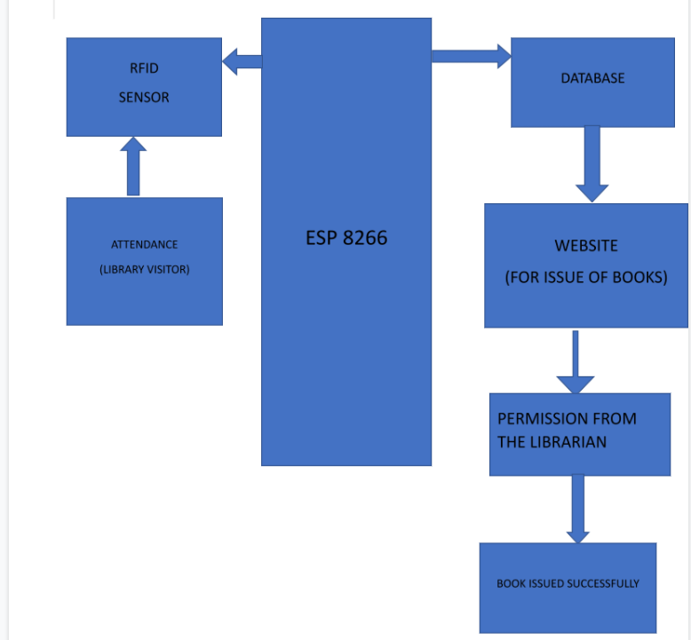

**Fig1-Block Diagram of Smart Library Management**

**CIRCUIT DIAGRAM**

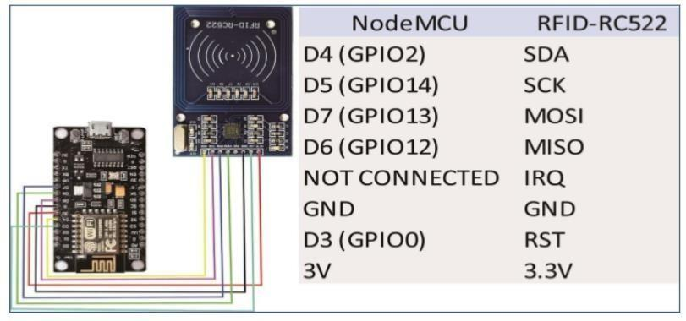

**Fig2-Figure of Circuit Diagram**

#### COMPONENT LIST

|  |  |
| --- | --- |
| Microcontroller(ESP8266) |  |
| RFID sensor(RC522) |  |
| LED |  |
| Jumper wire |  |
| Veroboard |  |

**PROCEDURE**

1. **Connecting the esp8266 with veroboard**:

We simply connect veroboard with esp8266

1. **Connecting the RFID sensor with wires and fixed it in a case**:

We fixed the RFID sensor with a case and then connect wires with three LED (one for authentication, one for power and one for internet).

1. **Circuit Implementation**:

The RC522 RFID module uses the SPI protocol to communicate with the ESP8266. The SPI communication uses specific boxes on this type of microcontroller.

The pinout is as follows (left side RC522, right side ESP8266):

* + Vcc <-> 3V3 (or Vin(5V) depending on the module version)
  + RST (Reset) <-> D0
  + GND (Ground) <-> GND
  + MISO (Master Input Slave Output) <-> D6
  + MOSI (Master Output Slave Input) <-> D7
  + SCK (Serial Clock) <-> D5
  + SS/SDA (Slave select) <-> D8

4. **Creating the database**:

We have created the database so that we can store the data and transfer from the hardware to the website. We have connected the database through Arduino code.

#### RESULTS AND ANALYSIS

1. 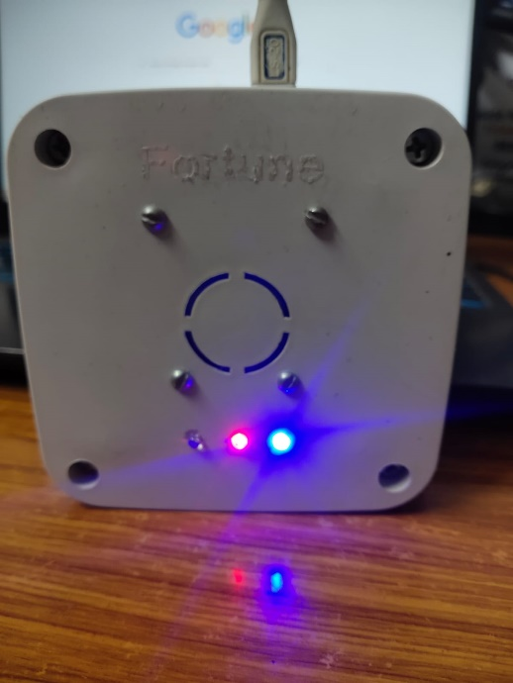**BLINKING OF LED USED FOR POWER AND INTERNET**: Here the red led indicates power supply. The blue light refers to the internet connectivity and we have a third led to know whether the user access is granted or denied.

**Fig 3-Figure of our Device**

1. **AUTHENTICATION**: Here we have used two cards one the sample card of RFID and the other is the metro card. We got the id’s of the above mentioned.

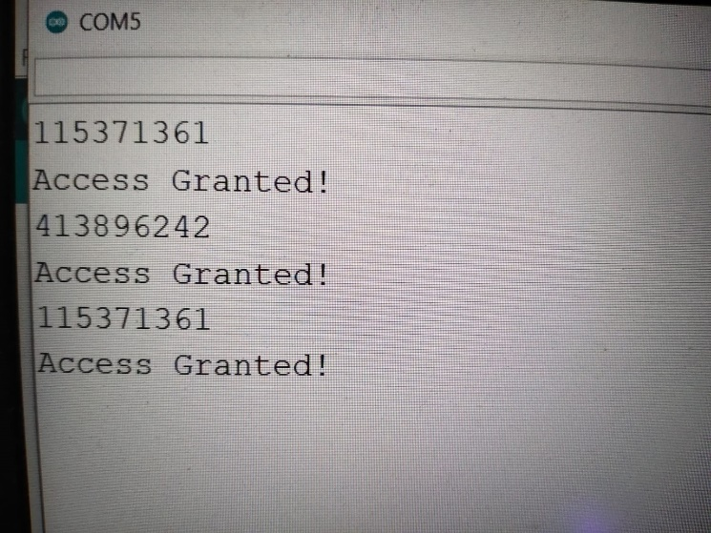

**Fig 4-Figure of Arduino IDE(Authentication)**

1. 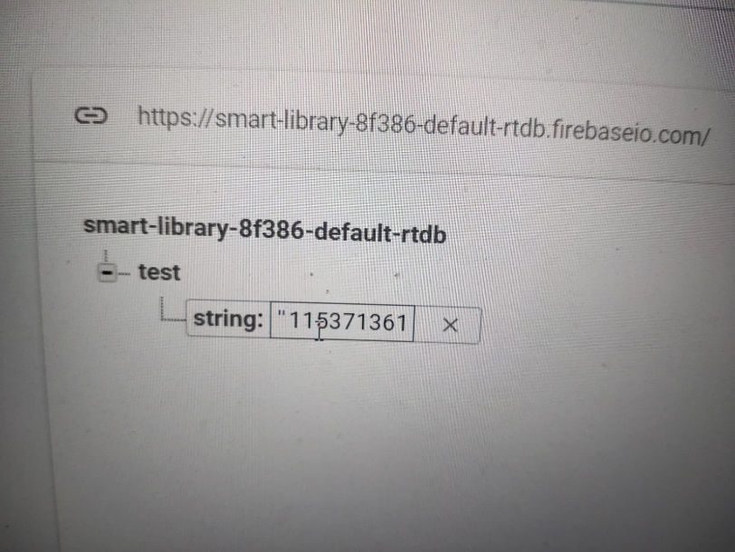**REFLECTION IN DATABASE**: Here the one who is granted his id is transferred to the database. We can calculate the attendance with this.

**Fig 5-Figure of Database (After Authentication)**

**CONCLUSION**

# Library plays very important role in developing knowledgeable society by providing knowledge and information to its users.

# The society can be well maintained with the help of our project Smart library management system.

# This system makes the library smart, remotely accessible and user/visitior friendly. This will also make issuing of the books hassle free.

# Keeping unwanted visitors at bay. Our project can be further improved by using ml and ai making a book recommendation system. This will make knowledge more accessible and following a system which can keep an easy track of the library.

# Library portals will make the library more user centric.

# This system can be implemented in universities, schools, colleges.

# This project will also help librarian to keep track of the books. In the age of digitalization Smart library management system can be put of a good use.

**FUTURE ASPECTS**

For future aspect the project can be extended in lots of ways like:

* Adding a recommendation system so that a reader will be recommended with books catered to their liking.
* Also adding a system so that readers can communicate and see each other’s requested books, comment on each other’s book so that future readers who wants to issue that book gets a review.
* A system can be implemented where each book can be rated according to some predefined formula that reflect that books popularity or its usefulness.
* It is also possible to add a feature so that readers can post their notes on a certain topic on the library site for future readers or even upload books in pdf format.
* Also, a feature to make pdf books also available to the readers can be another scope that we can explore.

In the end there are lots of ways to improve upon the system but the initial footing must be strong and the base system should always work and makes the library experience a breeze.

**Reference**

[1] Singh, T., & Sharma, A. (2015). [Research work and changing dimensions of digital library: A review](https://ieeexplore.ieee.org/document/7048169). 2015 4th International Symposium on Emerging Trends and Technologies in Libraries and Information Services.

[2] Puritat, K., & Intawong, K. (2020). [Development of an Open Source Automated Library System with Book Recommedation System for Small Libraries](https://ieeexplore.ieee.org/abstract/document/9090753). 2020 Joint International Conference on Digital Arts, Media and Technology with ECTI Northern Section Conference on Electrical, Electronics, Computer and Telecommunications Engineering (ECTI DAMT & NCON).

[3] Patnaik, R., & Mishra, M. K. (2015). [Role of Content Management Software (CMS) in libraries for information dissemination](https://ieeexplore.ieee.org/document/7048183). 2015 4th International Symposium on Emerging Trends and Technologies in Libraries and Information Services.

[4] Hu Haidong, Pan Dandan, & Wang Fangfang. (2011). [Analysis of digital library information services](https://www.researchgate.net/publication/254046683_Analysis_of_digital_library_information_services). 2011 IEEE International Symposium on IT in Medicine and Education.

[5] Felecia, Halim, S., & Wulandari, D. (2017). [Library facility layout design for digital native generation](https://ieeexplore.ieee.org/document/8290011). 2017 IEEE International Conference on Industrial Engineering and Engineering Management (IEEM).

[6] Sandhu, G. (2018). [The Role of Academic Libraries in the Digital Transformation of the Universities](https://ieeexplore.ieee.org/document/8485258). 2018 5th International Symposium on Emerging Trends and Technologies in Libraries and Information Services (ETTLIS).

[7] Arora, D. (2018). [Building Digital Library of Technology Focus Using Dspace](https://ieeexplore.ieee.org/document/8485231). 2018 5th International Symposium on Emerging Trends and Technologies in Libraries and Information Services (ETTLIS).

[8] Di Iorio, A., & Schaerf, M. (2014). [The Organization information integration in the management of a Digital Library System](https://ieeexplore.ieee.org/abstract/document/6970225). IEEE/ACM Joint Conference on Digital Libraries..

[9] Gupta, M., & Jetty, S. (2018). [Library in Everyone’s Pocket With reference to Bundelkhand University App](https://ieeexplore.ieee.org/document/8485206). 2018 5th International Symposium on Emerging Trends and Technologies in Libraries and Information Services (ETTLIS).